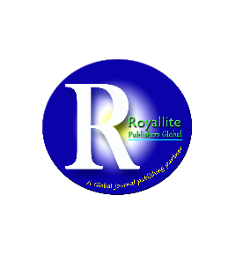
Royallite Global
Africa’s top academic publisher

ACADEMIC INTEGRITY AND REPORTING CENTRE
Research Journal in Advanced Research

Review Comments
Manuscript Title: Family Relations in the Age of Social Media: How Jordanians View the Influence of Facebook and WhatsApp
Author(s): UNKNOWN
Public Interest Statement: We follow the Recommendations for the Conduct, Reporting, Editing, and Publication of Scholarly works and Best Practice Guidelines for Journal Editors issued by the Committee on Publication Ethics (COPE); thus, it is our obligation to ensure that the works we publish meet the standards. Our focus as an academic publisher is to preserve the accuracy, integrity, and completeness of the scholarly record by ensuring that we promote honest and most-accurate publishing through stringent policies. Our team of experienced editors, reviewers, and advisors have sworn to respect and uphold these guidelines. For enquiries or comments on this particular article, kindly reach the editor through email, quoting the title of the paper: peer-review@royalliteglobal.com

Comments
Reviewer 1: Anonymous
- The abstract is not conclusive. It should be written in IMRAD method. Key important details are missing. It is also very short, kindly adjust it to about 200 words.
- Arrange the keywords in alphabetical order then separate them with a comma. In addition to that, reduce them to a maximum of seven words.
- The conclusion should not take the readers back to literature sources. As such, it should summarize the work. Your conclusion is unnecessarily longer than expected. You need to revise it to about 500 words.
- The work is very long. It should be revised to 7,000 words.

